Directions to

Body Cleanse Lymph Release
Office as of February 7th, 2022
501 Franklin Avenue, #10
Santa Fe, NM 87501
505.982.0044

In Santa Fe:
From the intersection of St. Francis and Agua Fria, turn west on Agua Fria (downhill, downstream). Go two short blocks on the left to Franklin Avenue. On the far left corner as you turn is 501 Franklin Avenue (the former massage school.) The parking lot entrance is on Franklin Avenue, or you may park in the two curbside parking spaces in front of 521 Franklin Avenue, and walk down. Please do not park in front of other homes.
From the 501 Franklin Avenue parking lot, walk to the back left corner of the lot, down the ramp, and right to the third office entrance on the back of the building, #10.

From Albuquerque:
North on I-25. North on St. Francis for several miles to the big intersection of Cerrillos and St. Francis . Two traffic lights further is Agua Fria. Left on Agua Fria, and then two short blocks to the left is Franklin Avenue. 501 Franklin Avenue is on the far left corner, with the entrance to the parking lot on Franklin Avenue.

Upon Arrival:
I have a “Come On In’ sign to welcome you. “Please Wait Outside” under the portal, if instructed.. I’ll open the door when I’m ready for you. Please come in, take off your shoes, and wash your hands.

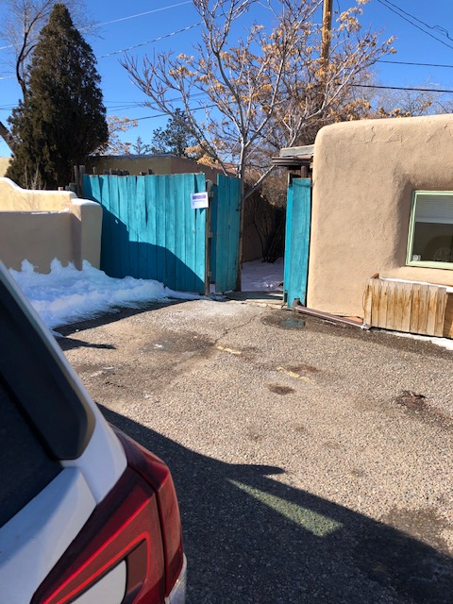

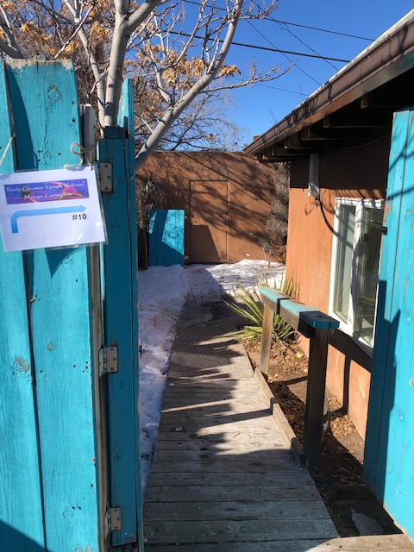

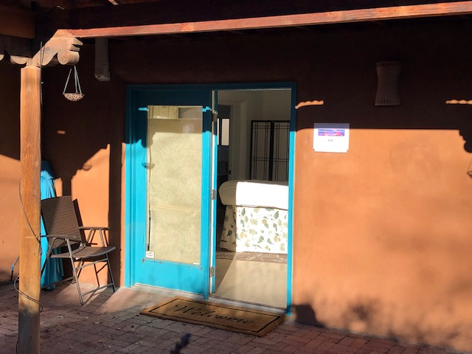
Margo Covington
Body Cleanse Lymph Release
501 Franklin Avenue, #10, Santa Fe 87501
TEL/TXT: 505.982.0044
BodyCleanseLymphRelease@gmail.com
www.BodyCleanseLymphRelease.com

